Supplementary material
Supplementary figure 1 Posterior predictive fit of reported symptomatic chikungunya cases across selected Brazilian states in 2022 2
Supplementary figure 2 Transmission-setting classification and model predicted 2022 chikungunya infection attack rates across selected Brazilian states. 3
Supplementary figure 3 Travel associated infection risk and SAE, and death benefit-risk across entry timing and travel duration. 4
Supplementary figure 4 SAE and death benefits and vaccine-associated risks under the reference outbreak-response immunisation scenario 5

Supplementary table 1 Predicted reporting rate by state and attack rate 10
Supplementary table 2 SAE averted (benefits) and vaccine- associated SAE (risks) for travel vaccination by travel duration, transmission setting, and age group. 11
Supplementary table 3 Deaths averted (benefits) and vaccine- associated deaths (risks) for travel vaccination by travel duration, transmission setting, and age group. 12
Supplementary table 4 SAEs averted (benefits) and vaccine associated SAEs (risks) under the reference outbreak response vaccination scenario by vaccine protection mechanism, serostatus based vaccine risk, and age group. The reference scenario assumed campaign initiation in week 2 and 50% target-age-group coverage. 13
Supplementary table 5 Deaths averted (benefits) and vaccine associated deaths (risks) under the reference outbreak response vaccination scenario by vaccine protection mechanism, serostatus based vaccine risk, and age group. The reference scenario assumed campaign initiation in week 2 and 50% target-age-group coverage. 14

Supplementary figure 1 Posterior predictive fit of reported symptomatic chikungunya cases across selected Brazilian states in 2022
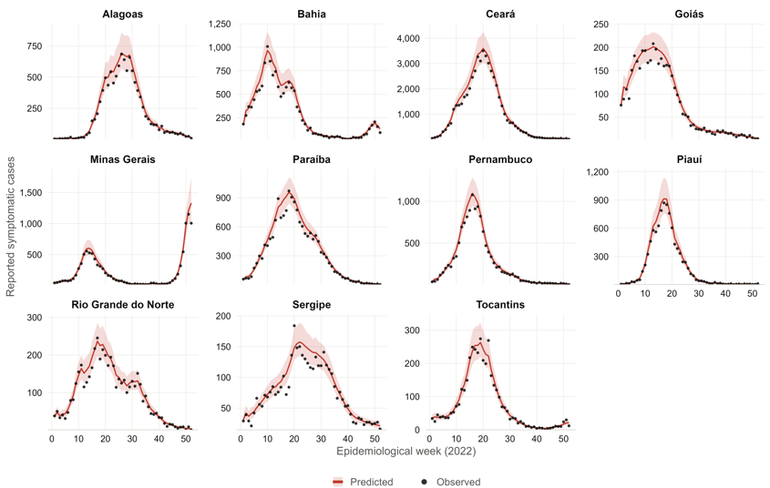

Supplementary figure 2 Transmission-setting classification and model predicted 2022 chikungunya infection attack rates across selected Brazilian states. Eleven Brazilian states included in the analysis, coloured by transmission setting (Figure 1A). Posterior cumulative infection attack rate by state. Points represent posterior medians and horizontal bars 95% UIs (Figure 1B). Peak weekly reported symptomatic case rate per million population. Dashed vertical lines indicate the thresholds used to classify transmission settings (Figure 1C).
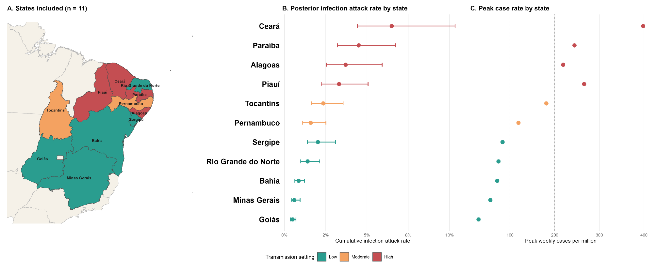
Supplementary figure 3 Travel associated infection risk and SAE, and death benefit-risk across entry timing and travel duration.
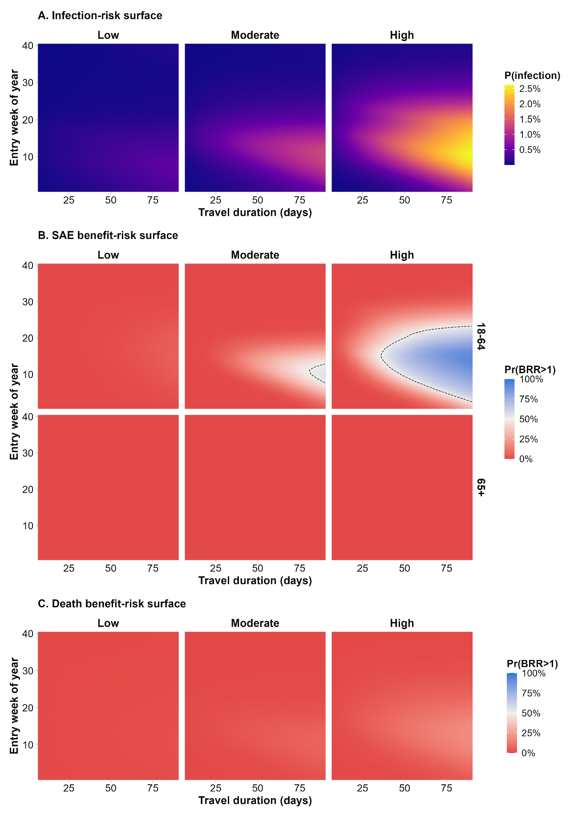
Supplementary figure 4 SAE and death benefits and vaccine-associated risks under the reference outbreak-response immunisation scenario
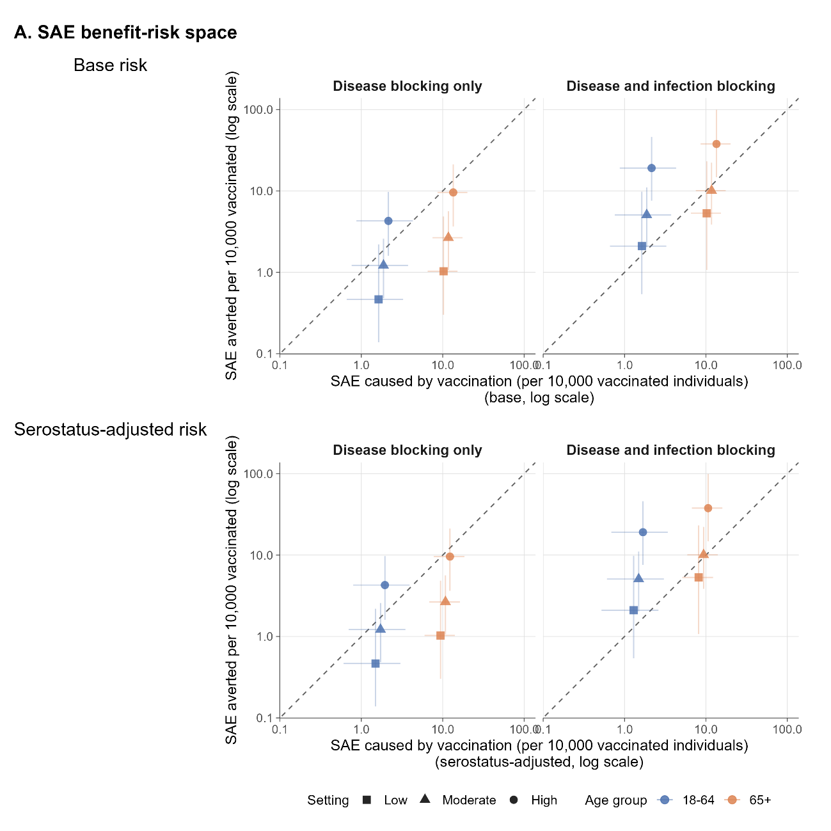

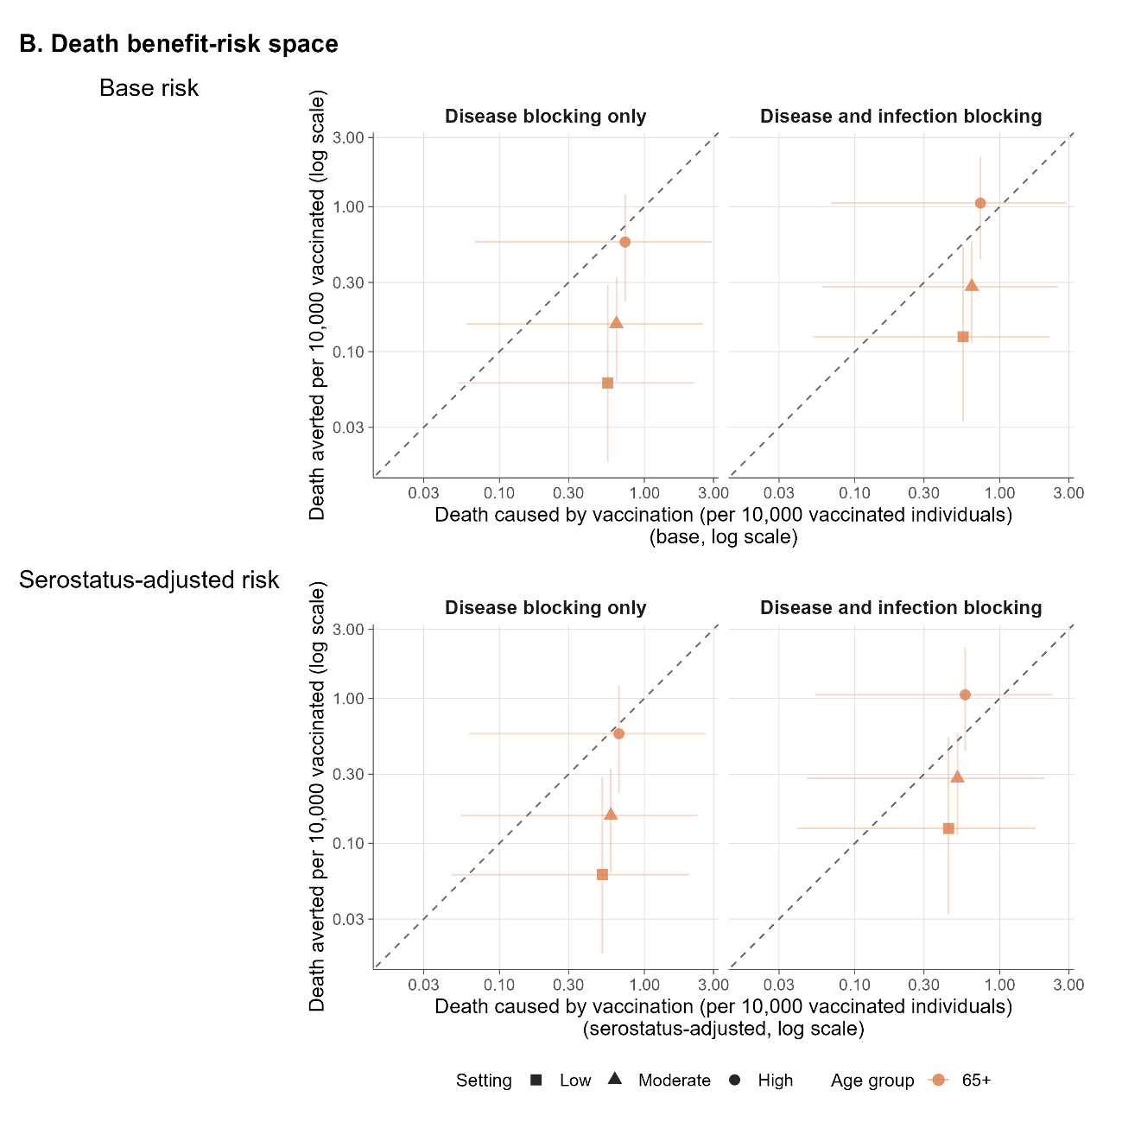

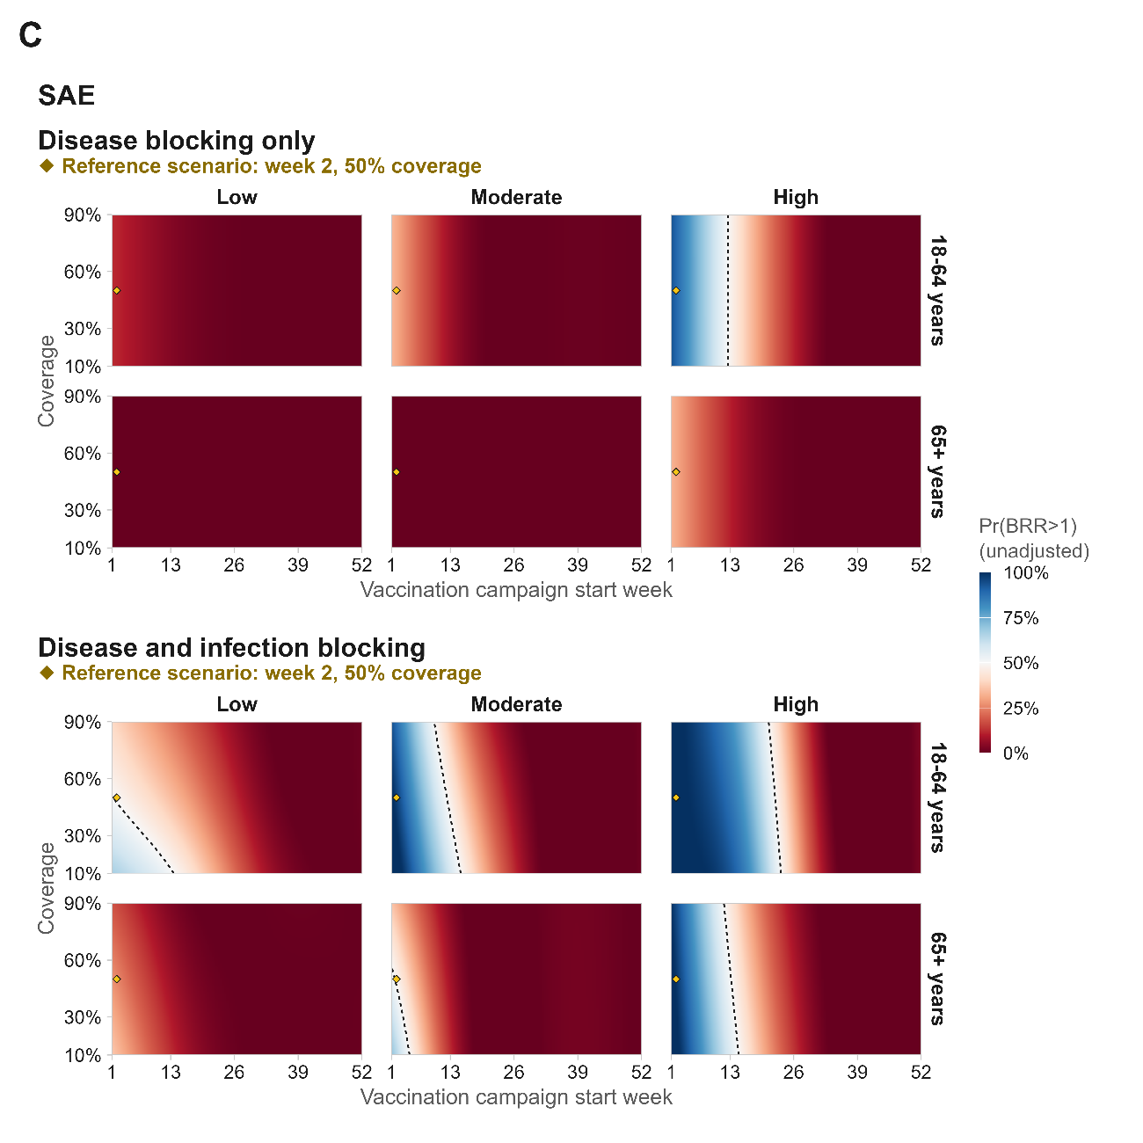
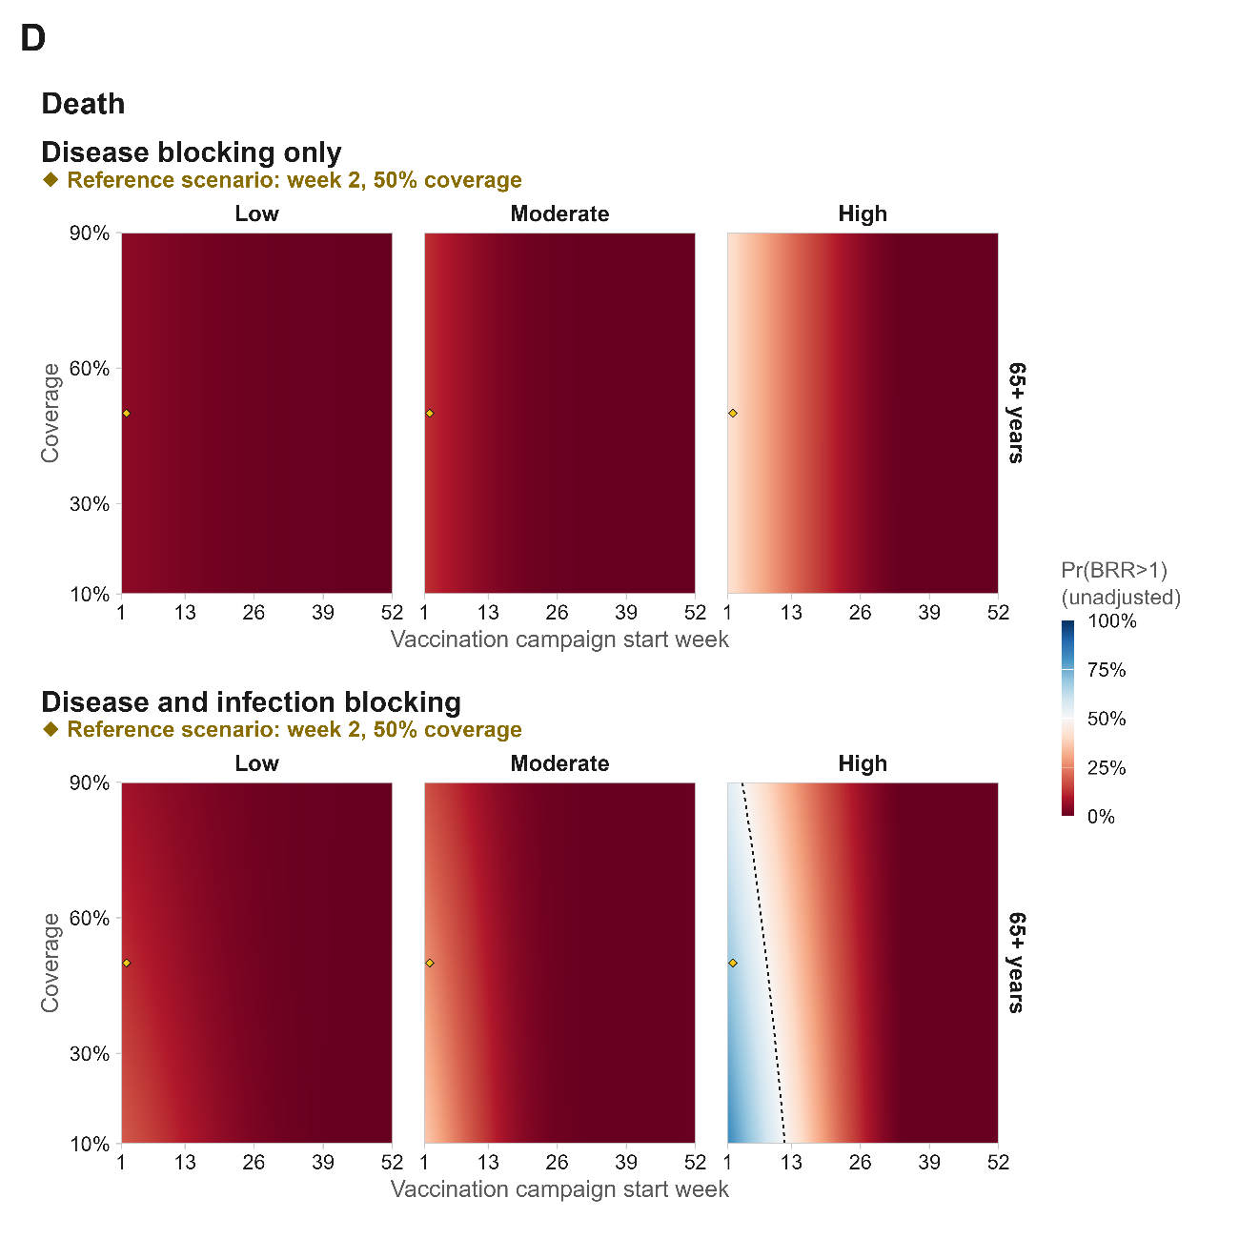

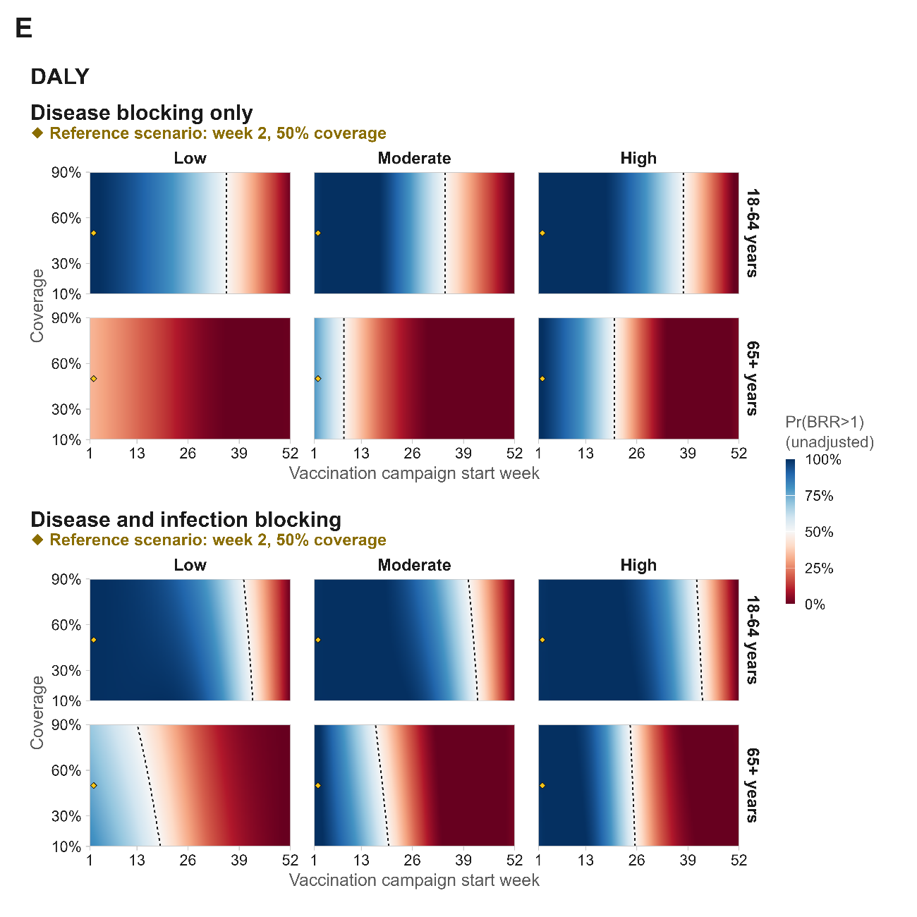

Supplementary table 1 Predicted reporting rate by state and attack rate
Setting | State | Predicted reporting rate, % (95% UI) | Resulting cumulative infection attack rate, % (95% UI)
Low | Goiás | 13.5 (9.6–17.9) | 0.5 (0.4–0.7)
Low | Minas Gerais | 12.6 (8.1–17.8) | 0.6 (0.4–0.9)
Low | Bahia | 14.5 (10.3–19.6) | 0.9 (0.6–1.2)
Low | Rio Grande do Norte | 12.3 (8.0–17.3) | 1.4 (1.0–2.1)
Low | Sergipe | 10.3 (6.9–15.1) | 2.0 (1.4–3.1)
Moderate | Pernambuco | 10.6 (6.7–15.2) | 1.6 (1.1–2.5)
Moderate | Tocantins | 12.2 (8.1–17.3) | 2.4 (1.6–3.6)
High | Piauí | 10.5 (6.9–15.6) | 3.3 (2.2–5.1)
High | Alagoas | 10.5 (6.5–15.1) | 3.7 (2.5–5.9)
High | Paraíba | 11.1 (7.4–15.4) | 4.5 (3.2–6.7)
High | Ceará | 10.6 (6.7–15.4) | 6.5 (4.4–10.3)
Reporting rate is a state-specific parameter fitted jointly with the transmission model in Stan, representing the fraction of true infections captured by the reported case surveillance data; median and 95% uncertainty interval across four Markov chains run for 5,000 iterations each, including 1,000 warm-up iterations, yielding 4,000 post warm-up draws per chain. True (reporting-adjusted) incidence = reported cases / reporting rate.

Supplementary table 2 SAE averted (benefits) and vaccine- associated SAE (risks) for travel vaccination by travel duration, transmission setting, and age group.
 |  | 7d |  |  | 14d |  |  | 30d |  |  | 90d
Transmission | Age group | Benefit | Risk | BRR | Benefit | Risk | BRR | Benefit | Risk | BRR | Benefit | Risk | BRR
Low | 18-64 | 0.01 (0.00–0.08) | 1.87 (0.76–3.74) | 0.01 (0.00–0.06) | 0.03 (0.01–0.15) | 1.87 (0.76–3.74) | 0.02 (0.00–0.12) | 0.05 (0.02–0.35) | 1.87 (0.76–3.74) | 0.03 (0.01–0.26) | 0.17 (0.06–1.20) | 1.87 (0.76–3.74) | 0.11 (0.03–0.95)
Low | 65+ | 0.01 (0.00–0.04) | 10.93 (6.85–16.39) | 0.00 (0.00–0.00) | 0.01 (0.00–0.07) | 10.93 (6.85–16.39) | 0.00 (0.00–0.01) | 0.03 (0.01–0.16) | 10.93 (6.85–16.39) | 0.00 (0.00–0.02) | 0.08 (0.03–0.58) | 10.93 (6.85–16.39) | 0.01 (0.00–0.06)
Moderate | 18-64 | 0.03 (0.01–0.06) | 1.87 (0.76–3.74) | 0.02 (0.00–0.05) | 0.06 (0.03–0.12) | 1.87 (0.76–3.74) | 0.03 (0.01–0.09) | 0.13 (0.06–0.27) | 1.87 (0.76–3.74) | 0.07 (0.02–0.22) | 0.63 (0.23–1.51) | 1.87 (0.76–3.74) | 0.34 (0.10–1.20)
Moderate | 65+ | 0.01 (0.01–0.03) | 10.93 (6.85–16.39) | 0.00 (0.00–0.00) | 0.03 (0.01–0.05) | 10.93 (6.85–16.39) | 0.00 (0.00–0.01) | 0.06 (0.03–0.13) | 10.93 (6.85–16.39) | 0.01 (0.00–0.01) | 0.31 (0.11–0.72) | 10.93 (6.85–16.39) | 0.03 (0.01–0.07)
High | 18-64 | 0.06 (0.01–0.18) | 1.87 (0.76–3.74) | 0.03 (0.00–0.14) | 0.14 (0.02–0.38) | 1.87 (0.76–3.74) | 0.07 (0.01–0.30) | 0.34 (0.06–0.91) | 1.87 (0.76–3.74) | 0.17 (0.03–0.71) | 1.82 (0.52–4.37) | 1.87 (0.76–3.74) | 0.96 (0.23–3.36)
High | 65+ | 0.03 (0.00–0.09) | 10.93 (6.85–16.39) | 0.00 (0.00–0.01) | 0.07 (0.01–0.18) | 10.93 (6.85–16.39) | 0.01 (0.00–0.02) | 0.16 (0.03–0.43) | 10.93 (6.85–16.39) | 0.01 (0.00–0.04) | 0.87 (0.23–2.02) | 10.93 (6.85–16.39) | 0.08 (0.02–0.21)

Supplementary table 3 Deaths averted (benefits) and vaccine- associated deaths (risks) for travel vaccination by travel duration, transmission setting, and age group.
 |  | 7d |  |  | 14d |  |  | 30d |  |  | 90d
Transmission | Age group | Benefit | Risk | BRR | Benefit | Risk | BRR | Benefit | Risk | BRR | Benefit | Risk | BRR
Low | 65+ | 0.00 (0.00–0.00) | 0.64 (0.06–2.53) | 0.00 (0.00–0.03) | 0.00 (0.00–0.01) | 0.64 (0.06–2.53) | 0.00 (0.00–0.06) | 0.00 (0.00–0.02) | 0.64 (0.06–2.53) | 0.01 (0.00–0.13) | 0.01 (0.00–0.07) | 0.64 (0.06–2.53) | 0.02 (0.00–0.46)
Moderate | 65+ | 0.00 (0.00–0.00) | 0.64 (0.06–2.53) | 0.00 (0.00–0.03) | 0.00 (0.00–0.01) | 0.64 (0.06–2.53) | 0.01 (0.00–0.06) | 0.01 (0.00–0.02) | 0.64 (0.06–2.53) | 0.01 (0.00–0.15) | 0.04 (0.01–0.09) | 0.64 (0.06–2.53) | 0.06 (0.01–0.79)
High | 65+ | 0.00 (0.00–0.01) | 0.64 (0.06–2.53) | 0.01 (0.00–0.08) | 0.01 (0.00–0.02) | 0.64 (0.06–2.53) | 0.01 (0.00–0.16) | 0.02 (0.00–0.05) | 0.64 (0.06–2.53) | 0.03 (0.00–0.41) | 0.11 (0.03–0.26) | 0.64 (0.06–2.53) | 0.17 (0.03–2.04)

Supplementary table 4 SAEs averted (benefits) and vaccine associated SAEs (risks) under the reference outbreak response vaccination scenario by vaccine protection mechanism, serostatus based vaccine risk, and age group. The reference scenario assumed campaign initiation in week 2 and 50% target-age-group coverage.
 |  | Disease blocking only (DB) |  |  |  |  | Disease and infection blocking (D+I)
Transmission | Age group | Benefit | Risk (base) | Risk (serostatus-adjusted) | BRR (base) | BRR (serostatus-adjusted) | Benefit | Risk (base) | Risk (serostatus-adjusted) | BRR (base) | BRR (serostatus-adjusted)
Low | 18-64 | 0.5 (0.1–2.2) | 1.9 (0.8–3.7) | 1.7 (0.7–3.5) | 0.3 (0.1–1.7) | 0.3 (0.1–1.8) | 2.1 (0.5–9.8) | 1.9 (0.8–3.7) | 1.5 (0.6–3.0) | 1.2 (0.2–7.6) | 1.5 (0.3–9.4)
Low | 65+ | 1.0 (0.3–4.9) | 11.7 (7.5–17.5) | 10.8 (6.9–16.2) | 0.1 (0.0–0.5) | 0.1 (0.0–0.5) | 5.3 (1.1–23.1) | 11.7 (7.5–17.5) | 9.3 (5.9–14.0) | 0.5 (0.1–2.2) | 0.6 (0.1–2.7)
Moderate | 18-64 | 1.2 (0.5–2.6) | 1.9 (0.8–3.7) | 1.7 (0.7–3.5) | 0.6 (0.2–2.2) | 0.7 (0.2–2.3) | 5.1 (2.0–11.0) | 1.9 (0.8–3.7) | 1.5 (0.6–3.0) | 2.8 (0.9–9.4) | 3.5 (1.1–11.5)
Moderate | 65+ | 2.7 (1.1–5.6) | 11.7 (7.5–17.5) | 10.8 (6.8–16.2) | 0.2 (0.1–0.6) | 0.3 (0.1–0.6) | 10.1 (3.9–22.2) | 11.7 (7.5–17.5) | 9.4 (5.9–14.0) | 0.9 (0.3–2.2) | 1.1 (0.4–2.7)
High | 18-64 | 4.3 (1.6–9.7) | 1.9 (0.8–3.7) | 1.7 (0.7–3.4) | 2.3 (0.7–7.7) | 2.5 (0.8–8.2) | 19.1 (7.6–45.9) | 1.9 (0.8–3.7) | 1.5 (0.6–3.0) | 10.5 (3.2–35.2) | 13.3 (4.2–43.8)
High | 65+ | 9.6 (3.6–21.2) | 11.7 (7.5–17.5) | 10.7 (6.8–16.0) | 0.8 (0.3–2.0) | 0.9 (0.3–2.1) | 37.8 (14.8–99.4) | 11.7 (7.5–17.5) | 9.3 (5.8–13.9) | 3.2 (1.1–9.4) | 4.1 (1.6–11.4)

Supplementary table 5 Deaths averted (benefits) and vaccine associated deaths (risks) under the reference outbreak response vaccination scenario by vaccine protection mechanism, serostatus based vaccine risk, and age group. The reference scenario assumed campaign initiation in week 2 and 50% target-age-group coverage.
 |  | Disease blocking only (DB) |  |  |  |  | Disease and infection blocking (D+I)
Transmission | Age group | Benefit | Risk (base) | Risk (serostatus-adjusted) | BRR (base) | BRR (serostatus-adjusted) | Benefit | Risk (base) | Risk (serostatus-adjusted) | BRR (base) | BRR (serostatus-adjusted)
Low | 65+ | 0.06 (0.02–0.29) | 0.64 (0.06–2.53) | 0.59 (0.05–2.33) | 0.12 (0.01–1.98) | 0.13 (0.01–2.17) | 0.13 (0.03–0.54) | 0.64 (0.06–2.53) | 0.51 (0.05–2.02) | 0.23 (0.02–3.86) | 0.29 (0.03–4.80)
Moderate | 65+ | 0.16 (0.06–0.33) | 0.64 (0.06–2.53) | 0.59 (0.05–2.32) | 0.25 (0.04–2.85) | 0.27 (0.05–3.10) | 0.28 (0.11–0.58) | 0.64 (0.06–2.53) | 0.51 (0.05–2.03) | 0.45 (0.08–5.04) | 0.56 (0.11–6.51)
High | 65+ | 0.57 (0.22–1.22) | 0.64 (0.06–2.53) | 0.58 (0.05–2.31) | 0.89 (0.17–10.95) | 0.97 (0.19–11.79) | 1.06 (0.43–2.22) | 0.64 (0.06–2.53) | 0.50 (0.05–1.99) | 1.64 (0.32–19.83) | 2.09 (0.41–24.86)

Benefit risk assessment equations for travel vaccination

Chikungunya infection attributable outcomes per 10,000 travellers among vaccinated and unvaccinated individuals
Natural infections outcomes are derived from the travel-specific attack rates ${AR}_{s,a,d}^{t}$. For 10,000 travellers in state $s,$age group $a$, travel duration $d$, under vaccination status $x ∈\left\{U, V\right\}:$

$${Symptomatic}_{10k}^{x,DZ}\left(s,a,d\right)=10,000 ∙ {AR}_{s,a,d }^{t}∙S$$
$${Deaths}_{10k}^{x,DZ}\left(s,a,d\right)=10,000 ∙ {AR}_{s,a,d}^{t} ∙ S ∙ f_{a}$$

$${Hosp}_{10k}^{x,DZ}\left(s,a,d\right)=10,000 ∙ {AR}_{s,a,d}^{t} ∙ S∙ h_{a}$$

$${Nonhosp}_{10k}^{x,DZ}\left(s,a,d\right)=10,000 ∙ {AR}_{s,a,d}^{t} ∙ S∙ (1-h_{a})$$

$${Subac}_{10k}^{x,DZ}\left(s,a,d\right)=10,000∙ {AR}_{s,a,d}^{t} ∙ S ∙π_{sub}$$

$${Chr}_{10k}^{x,DZ}=10,000 ∙ {AR}_{s,a,d}^{t} ∙ S ∙π_{chr}$$
Where $S$ is a symptomatic fraction, $f_{a}$ is the age-specific case fatality rate, $h_{a}$ is the age specific hospitalisation rate given symptomatic infection, and $π_{sub}$ and $π_{chr}$ are proportions progressing to sub-acute and chronic phases among symptomatic patients. For unvaccinated ($x=U)$, ${AR}^{t,(u)}={AR}^{t}$ and for vaccinated, ${AR}^{t,(V)}={AR}^{t}∙\left(1-VE\right).$
Chikungunya infection related SAEs are defined as the sum of hospitalisations and deaths:
$${SAE}_{10k}^{x,DZ}\left(s,a,d\right)={Hosp}_{10k}^{x,DZ}\left(s,a,d\right)+ {Deaths}_{10k}^{x,DZ}\left(s,a,d\right)$$

Vaccine attributable DALYs are computed from vaccine-attributable SAEs and deaths.
$${DALY}_{x}^{DZ }\left(s,a,d\right)= {YLD}_{x}^{DZ }(s,a,d)+{YLL}_{x}^{DZ }\left(s,a,d\right)$$

$${YLL}_{x}^{DZ}\left(s,a,d\right)={Deaths}_{10k,x}^{DZ}\left(s,a,d\right)∙e_{a} (x ∈\{U, V\})$$

$${YLD}_{x}^{DZ }={YLD}_{x}^{DZ,acute,hosp}\left(s,a,d\right)+ {YLD}_{x}^{DZ,acute,nonhosp}\left(s,a,d\right)+ {{YLD}_{x}^{DZ,subac}\left(s,a,d\right)+ YLD}_{x}^{DZ,6m_chr}\left(s,a,d\right)+ {YLD}_{x}^{DZ,12m_chr}\left(s,a,d\right)+{YLD}_{x}^{DZ,30m_chr }\left(s,a,d\right)$$

Where each component is:
$${YLD}_{x}^{DZ,acute,hosp}\left(s,a,d\right)={Hosp}_{10k}^{x,DZ}\left(s,a,d\right) ∙dw_{H} ∙d_{acute}$$

$${YLD}_{x}^{DZ,acute,nonhosp}\left(s,a,d\right)={Nonhosp}_{10k}^{x,DZ}\left(s,a,d\right) ∙dw_{NH} ∙d_{nonhosp}$$

$${YLD}_{x}^{DZ,subac}\left(s,a,d\right)={Subac}_{10k}^{x,DZ}\left(s,a,d\right) ∙dw_{subac} ∙d_{subac}$$

$${YLD}_{x}^{DZ,6m_chr}\left(s,a,d\right)={Chr}_{10k}^{x,DZ}\left(s,a,d\right) ∙dw_{chr} ∙d_{chr,6m}$$
$${YLD}_{x}^{DZ,12m_chr}\left(s,a,d\right)={Chr}_{10k}^{x,DZ}\left(s,a,d\right) ∙dw_{chr} ∙d_{chr,12m}$$

$${YLD}_{x}^{DZ,30m_{chr}}\left(s,a,d\right)={Chr}_{10k}^{x,DZ}\left(s,a,d\right) ∙dw_{chr} ∙d_{chr,30m}$$

The benefit per 10,000 travellers for each outcome Y $∈\{SAE, Death,DALY\}$ is:

$$Benefit_{y}\left(s,a,d\right)= Y^{U}\left(s,a,d\right)- Y^{V}\left(s,a,d\right)$$

Risk scenario
We assumed that individuals receiving travel vaccination originate from non-endemic regions without autochthonous CHIKV transmission and are therefore fully seronegative. Vaccine-attributable risk is applied equally to all travellers. Vaccine-attributable non-fatal SAE and death probabilities, $p_{\text{SAE}∣\text{vacc},a,k}$ and $p_{\text{death}∣\text{vacc},a,k}$, were sampled from age-specific Jeffreys Beta distributions derived from the FDA suspension memo linelist. Vaccine-attributable SAEs and deaths per 10,000 travellers are
$${SAE}_{10k}^{vacc}\left(a,k\right)=10,000 ∙[P_{nonfatal_sae|vacc}^{base}\left(a,k\right)+ P_{death|vacc}^{base}\left(a,k\right)]$$

$${Death}_{10k}^{vacc}\left(a,k\right)=10,000 ∙ P_{death|vacc}^{base}(a,k)$$

$${\text{DALY}}_{10k}^{\text{vacc}}(a,k)={\text{SAE}}_{10k}^{\text{vacc}}(a,k)⋅dw_{H}⋅d_{\text{acute}}+{\text{Death}}_{10k}^{\text{vacc}}(a,k)⋅e_{a}$$

Because travellers were assumed to originate from non-endemic regions and to be fully seronegative, we report a single risk estimate for travel vaccination.

Benefit risk ratio
The draw level BRR is computed for each outcome:

$${BRR}_{SAE}^{10k}\left(s,a,d,k\right)=\frac{Benefit_{sae}\left(s,a,d\right)}{{SAE}_{10k}^{vacc}\left(a,k\right)}$$

$${BRR}_{death}^{10k}\left(s,a,d,k\right)=\frac{Benefit_{death}\left(s,a,d\right)}{{Death}_{10k}^{vacc}\left(a,k\right)}$$

$${BRR}_{DALY}^{10k}\left(s,a,d,k\right)=\frac{Benefit_{daly}\left(s,a,d\right)}{{DALY}_{10k}^{vacc}\left(a,k\right)}$$

Benefit risk assessment equations for outbreak response immunisation

Benefit: outcomes averted per 10,000 vaccinated individuals

In outbreak setting, burden is obtained from age-structured SEIRV model simulations under counterfactual (no vaccination) and vaccination scenarios with vaccine coverage.
For each probabilistic draw $k$,state $s$, age group $a$, Vaccine protection mechanism $v,$ the estimated benefit is the difference in true disease burden between pre- and post- vaccination states, expressed per 10,000 vaccinated individuals.
True symptomatic burden $Y_{a,t,s,l}^{true_symp }$ was estimated by applying model-predicted state-specific reporting rates $ρ_{s,k}$ estimated during model fitting.
$$Y_{a,t,s,l}^{true_symp }=\frac{Y_{a,t,s,k}^{symp}}{ρ_{s,k}}$$
For age group a, hospitalisations and deaths from chikungunya infections are estimated as:
$${Hosp}_{a,k}= Y_{a,k}^{symp}∙h_{a}$$
$$N{onhosp}_{a,k}=Y_{a,k}^{symp}∙{(1-h}_{a})$$
$$Subac_{a,k}=Y_{a,k}^{symp}∙π_{sub}$$
$${Chr}_{a,k}=Y_{a,k}^{symp}∙π_{chr}$$
$${Death}_{a,k}={Hosp}_{a,k} ∙ f_{a}^{H}+N{onhosp}_{a,k}∙ f_{a}^{NH}$$
Where $h_{a}$ is the age-specific hospitalisation rate given symptomatic infection, and $f_{a}^{H},$ $f_{a}^{NH}$ are the age-specific case fatality rates among hospitalised and non-hospitalised individuals, respectively.
Serious adverse events (SAEs) from chikungunya are defined as the sum of hospitalisations and deaths:
$$SAE_{a,k}={Hosp}_{a,k}+{Death}_{a,k}$$
Chikungunya infection-related DALYs were calculated as the sum of years of life lost (YLL) and years lived with disability (YLD) where YLD captures acute, subacute, and chronic disease phases. Chronic disease phases are divided into three phases based on duration of illness (3-6 months, 6-12 months, 12-30 months).
$$DALY_{a,k}=YLD_{a,k}+YLL_{a,k}$$

$$YLL_{a,k}={Death}_{a,k }∙e_{a}$$

$$YLD_{a,k}=\left({Hosp}_{a,k }∙{dw}_{H }+N{onhosp}_{a.k} ∙{dw}_{NH }\right)+ {Subac}_{a,k }​⋅dw_{sub}​⋅d_{sub}​+{Chr}_{a,k }​⋅dw_{chr}​⋅(d_{chr,6m}+d_{chr,12m}+d_{chr,30m}​)$$
Where $e_{a}$ is the remaining life expectancy at death for each age group a; ${dw}_{H }$, ${dw}_{NH }$, ${dw}_{chr }$are disability weights for hospitalised, non-hospitalised, sub-acute, and chronic phases; $d$ denotes the corresponding durations of illness; and $π_{sub}$, $π_{chr}$ are proportions progressing to sub-acute and chronic phases.
The benefit per 10,000 vaccinated individuals is:
$$B_{10k}^{\left(v\right)}\left(s,a,v,k\right)=10,000 ∙ \frac{Y_{pre}^{\left(v\right)}\left(s,a,v,k\right)- Y_{post}^{\left(v\right)}\left(s,a,v,k\right)}{N_{vacc}(s,a,v)}$$
Where, $Y$ $∈\{SAE, Death, DALY\}$, and $N_{vacc}(s,a,v)$ is the total number of vaccinated individuals in age group $a$ under strategy $v$.
Vaccine protection mechanisms are: (i) protection against disease only, and (ii) protection against both disease and infection. Vaccination strategy: (i) vaccinating individuals aged 18-64 years only, and (ii) vaccinating older adults aged ≥ 65 years only.

Risk scenarios
- Baseline unadjusted risk
In the baseline unadjusted risk scenario, all vaccinated individuals regardless of serostatus at vaccination are assumed to face equal vaccine-attributable risk.
Vaccine attributable non-fatal SAE and death probabilities, $p_{nonfatal_sae|vacc,a,k}$ and $p_{death|vacc,a,k}$, were sampled from uncertainty distributions (Table S 1). The number of non-fatal SAEs and deaths were derived from US FDA suspension memo. Vaccine attributable SAEs and deaths per 10,000 vaccinated individuals are:
- Seroprevalence adjusted risk
In the adjusted scenario, seropositive individuals at the time of vaccination are assumed to have pre-existing immunity that reduces vaccine-attributable risk by a factor $RR_{seropos}=0$ which implies no-risk in seropositive. We do not model partial protection against severe outcomes given infection among those with waning immunity, as empirical data on severity given re-infection are lacking.

$$P_{sae|vacc}^{adj}=q_{seroneg} ∙ P_{nonfatal_sae|vacc}^{base}+q_{seropos} \left(RR_{seropos} ∙ P_{nonfatal_sae|vacc}^{base}\right)$$

$$P_{death|vacc}^{adj}=q_{seroneg} ∙ P_{death|vacc}^{base}+q_{seropos} \left(RR_{seropos} ∙ P_{death|vacc}^{base}\right)$$

Here, the $RR_{seropos}$ = 0 for seropositive individuals, and $q_{seropos}$ is the proportion of seropositive, and $q_{seroneg}$ is the proportion of seronegative individuals.

Vaccination attributable outcomes per 10,000 vaccinated individuals
Based on the probabilities of non-fatal SAE and death, the number of SAEs and deaths in Baseline unadjusted risk scenarios are represented as below:
- SAEs and deaths under baseline unadjusted risk scenario
$${SAE}_{10k}^{vacc}\left(a,k\right)=10,000 ∙[P_{nonfatal_sae|vacc}^{base}\left(a,k\right)+ P_{death|vacc}^{base}\left(a,k\right)]$$
$${Death}_{10k}^{vacc}\left(a,k\right)=10,000 ∙ P_{death|vacc}^{base}(a,k)$$

- SAEs and deaths under seroprevalence adjusted risk scenario
$${SAE}_{10k}^{vacc}\left(a,k\right)=10,000 ∙[P_{sae|vacc}^{adj}\left(a,k\right)+ P_{death|vacc}^{adj}\left(a,k\right)]$$
Vaccine attributable DALYs are computed from vaccine-attributable SAEs and deaths. We assumed that the SAE cases from vaccines also progress into sub-acute and chronic phases as natural chikungunya infection, for two reasons. First, VLA1553 is a live-attenuated vaccine that elicits immune responses similar in breadth to those of natural chikungunya infection, and post-vaccination chikungunya like illness reactions in clinical trials have shown durations ranging from 1 to 182 days, with prolonged symptoms (≥ 30 days) in 0.5% of vaccinees. Second, this assumption is conservative for benefit risk estimates because attributing chronic disability to vaccine-attributable SAEs increases the vaccine-attributable DALY denominator and thus reduces estimated BRRs.
As SAEs are defined as severe chikungunya-like illness reactions those that prevented daily activity and/or required medical intervention, we used hospitalisation as a proxy for non-fatal SAE.
$${DALY}_{10k}^{vacc}\left(a,k\right)={YLD}_{10k}^{vacc}\left(a,k\right)+ {YLL}_{10k}^{vacc}(a,k)$$
$${YLD}_{10k}^{vacc}\left(a,k\right)={SAE}_{10k}^{vacc}\left(a,k\right) ∙dw_{H} ∙d_{acute} + {SAE}_{10k}^{vacc}\left(a,k\right) ∙dw_{H} ∙d_{acute}+ {SAE}_{10k}^{vacc}\left(a,k\right)⋅π_{sub}​⋅dw_{sub}​⋅d_{sub}​+{SAE}_{10k}^{vacc}\left(a,k\right)⋅π_{chr}​⋅dw_{chr}​⋅(d_{chr,6m}+d_{chr,12m}+d_{chr,30m}$$
$${YLL}_{10k}^{vacc}\left(a,k\right)= {Death}_{10k}^{vacc}\left(a,k\right)∙e_{a}$$

Benefit risk ratio
The draw level BRR is computed as

$${BRR}_{SAE}^{10k}\left(s,a,k\right)=\frac{B_{10k}^{\left(v\right)}\left(s,a,v,k\right)}{{SAE}_{10k}^{vacc}\left(a,k\right)}$$

$${BRR}_{death}^{10k}\left(s,a,k\right)=\frac{B_{10k}^{\left(v\right)}\left(s,a,v,k\right)}{{Death}_{10k}^{vacc}\left(a,k\right)}$$

$${BRR}_{DALY}^{10k}\left(s,a,k\right)=\frac{B_{10k}^{\left(v\right)}\left(s,a,v,k\right)}{{DALY}_{10k}^{vacc}\left(a,k\right)}$$

